**Requirement Analysis**: The researches are going to conduct a series of tests to gather data from the respondents. The first test contains an application where it displays an object randomly at a time, while the user's objective is to hit the objects as accurately, and efficiently as possible. The second test is somehow similar to the first one but the object that the user must target is surrounded by multiple distractions. The third test is where the participants must repetitively hit the given targets which are randomly placed near the edges of the canvas. The fourth one is where the participants must select and move the target object by dragging it to another location of the canvas. The fifth test is where the participants must be as fast and accurate at using the keypad. The last or sixth test contains a circle on the canvas which the participants must trace. These tests intend to obtain data such as the accuracy, speed, error ratio, and response time which are essential in defining the factors relevant to the History entity in the paper’s diagrams.

**Requirement Documentation:**

**Gap Analysis:** The researchers’ current prototype working features are Perform Calibration and Report. Although these features are working, there are still missing parts of it. One of the missing parts that is supposed to be included in the system is a database for all the data to put into. Currently, the calibration tests being performed are not stored in a database, the calibration results are just shown on the screen.

**Design of Software, Systems, Product, and Processes:**

**Development and Testing:**

**Description of Prototype:**  This prototype’s main function is to calibrate the user’s smartphone touch register to its optimal form. Each calibration result alters or adapts the smartphone’s system depending on the results gathered from the user. The main features that this application have are the following: Report, Check History, and the most important, Perform Calibration. In Report, the users can send their feedbacks in support to strengthening the effectiveness of the application. In Check History, the user can select their past calibration results in order to apply it to the smartphone’s system. In Perform Calibration, the user will perform gestures to process the calibration.

**Population and sample**: The population of interest for this study are the individuals residing in Metro Manila who have concerns or problems regarding touchscreen responsiveness.

**Sampling technique**: The researchers are using stratified sampling to acquire the sample of the research under discussion. This method belongs to the category of random sampling technique, and works by dividing the population or participants into multiple groups from which are then sampled randomly.

**Gathering Procedure**: The researchers are providing six tests to the participants. The first test is there to determine which size is the most suitable for the object. The second test is similar to the first one but it determines also the proper size for the distraction objects. The third test meanwhile gets the optimal minimum distance of the object from the canvas. The fourth test gets the error ratio and average time for a typical task completion to give better insights to the usability of the touchscreen regarding drag and drop. The purpose of the fifth test is to get the best dimension and spacing values for a certain set of interactive controls. Lastly the sixth test is there to calculate the response time.

**Nature of the Study:** The researchers are creating a goal-oriented research, focusing on representation to understand the human computer interaction specifically between touchscreen and user(s). Under goal-based research, there are two types, representation and generalization. The researchers are using representation, an in-depth understanding of a certain phenomenon, understanding how factors affect a situation.

**Data Analysis:**

The formula that the researchers are using is based from Google Android’s touch resampling algorithm. This formula gives values that can be compared in order to show the changes that happens between calibrations.

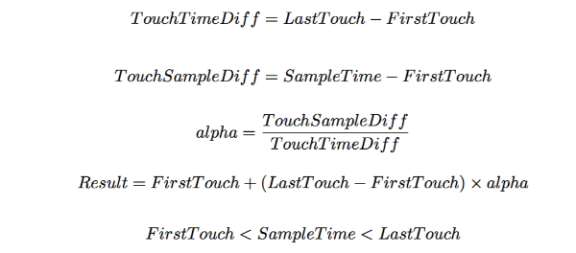

**Data analysis**

**http://androidxref.com/4.4.4_r1/xref/frameworks/native/libs/input/InputTransport.cpp#675**

[**http://www.masonchang.com/blog/2014/8/25/androids-touch-resampling-algorithm**](http://www.masonchang.com/blog/2014/8/25/androids-touch-resampling-algorithm)

**The rest**

**http://www.riteh.uniri.hr/~sljubic/publications/hcii11.pdf**